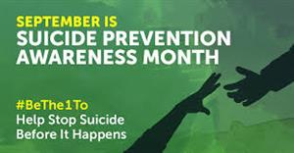

**September is Suicide Prevention Awareness Month**

Being knowledgeable about the warning signs can make all the difference!

Be a friend...

Be an ear...

Just Be there...

#BeTheOneTo  ... Save a Life

**Warning Signs:**

The warning signs of suicide are indicators that a person may be in acute danger and may urgently need help.

* Talking about wanting to die or to kill oneself;
* Looking for a way to kill oneself;
* Talking about feeling hopeless or having no purpose;
* Talking about feeling trapped or being in unbearable pain;
* Talking about being a burden to others;
* Increasing the use of alcohol or drugs;
* Acting anxious, agitated, or reckless;
* Sleeping too little or too much;
* Withdrawing or feeling isolated;
* Showing rage or talking about seeking revenge; and
* Displaying extreme mood swings.

